Access Delegation - OAuth 2.0

Introduction:
In this tutorial, you will experience how the WSO2 Identity Server (WSO2 IS) can be used as an OAuth 2.0 authorization server. This tutorial guides you through the OAuth 2.0 application configuration, deployment, and usage scenario.

In this sample, a user will try to login to a web application called pickup-dispatch via a WSO2 Identity Server and get an access token to call the API to view the vehicle bookings.
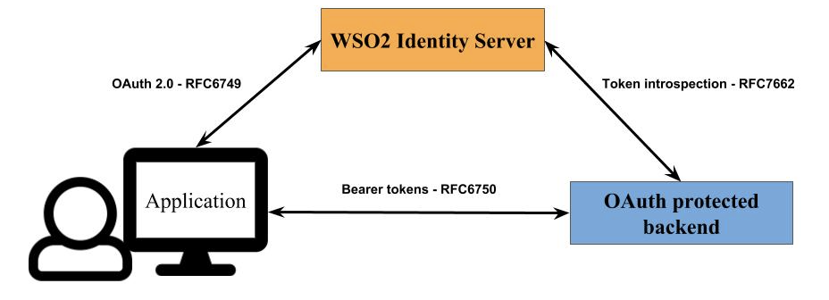

Setting up:

- Get the pickup-dispatch.war sample application from the SampleApps folder provided with this training. This version already contains the WSO2 Identity Server 7.3.0 keystore (wso2carbon.p12) and reads claims through the REST API, so no keystore copy or extra server configuration is needed.
Note: If you use an older sample from GitHub instead, (1) copy <IS_HOME>/repository/resources/security/wso2carbon.p12 to <TOMCAT_HOME>/webapps/pickup-dispatch/WEB-INF/classes/, (2) change every localhost.com in dispatch.properties to localhost, and (3) add enable_admin_services = true under [server] in <IS_HOME>/repository/conf/deployment.toml and restart WSO2 Identity Server. Otherwise the ClaimMetadataManagementService call fails in the Tomcat logs.
- Set up Apache Tomcat 9 and deploy pickup-dispatch.war:
  - Extract the Apache Tomcat 9 zip. The extracted folder is called <TOMCAT_HOME> below.
  - Make sure the JAVA_HOME environment variable points to your JDK (21 or 25).
  - Copy pickup-dispatch.war into <TOMCAT_HOME>/webapps.
  - Start Tomcat from <TOMCAT_HOME>/bin. It listens on port 8080:
Windows (Command Prompt):
cd <TOMCAT_HOME>\bin
catalina.bat start
Linux / macOS (Terminal):
cd <TOMCAT_HOME>/bin
sh catalina.sh start
  - Open http://localhost:8080 and check that the Tomcat page loads. To stop Tomcat, run catalina.bat stop (Windows) or sh catalina.sh stop (Linux/macOS) from the same folder.
  - Tomcat deploys the WAR automatically and creates the folder <TOMCAT_HOME>/webapps/pickup-dispatch.
- Configure pickup dispatch application as a service provider in WSO2 Identity Server.
- In the WSO2 Identity Server Console, from the menu click Applications.
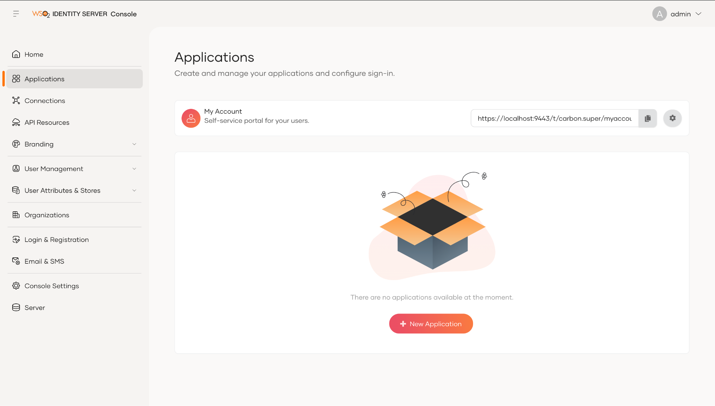
- Click New Application.
- From the given set of templates select Traditional Web Application template.
- Fill the fields in the create application wizard.
Name: Pickup Dispatch
Authorized redirect URLs: http://localhost:8080/pickup-dispatch/oauth2client
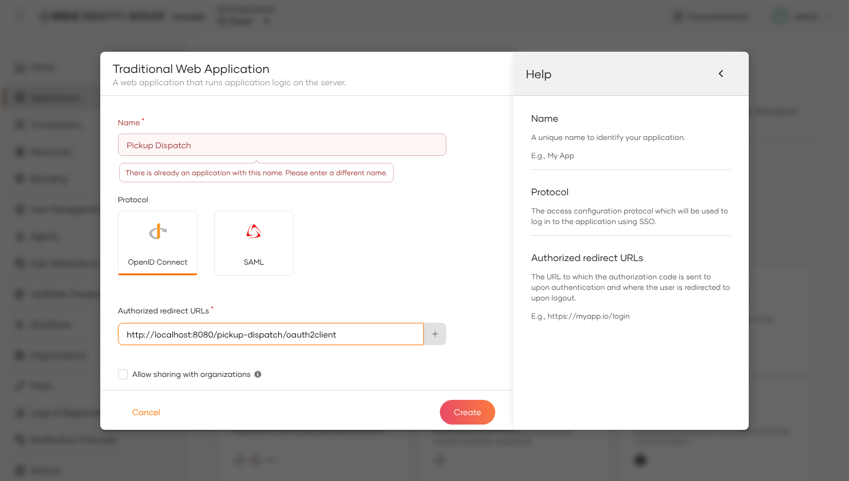

- Goto Protocol tab and note Client ID and Client Secret.
- Open <TOMCAT_HOME>/webapps/pickup-dispatch/WEB-INF/classes/dispatch.properties.
- Replace consumerKey and consumerSecret values with Client ID and Client Secret taken from the newly created service provider. And be sure the value of scope is “openid internal_application_mgt_view”.
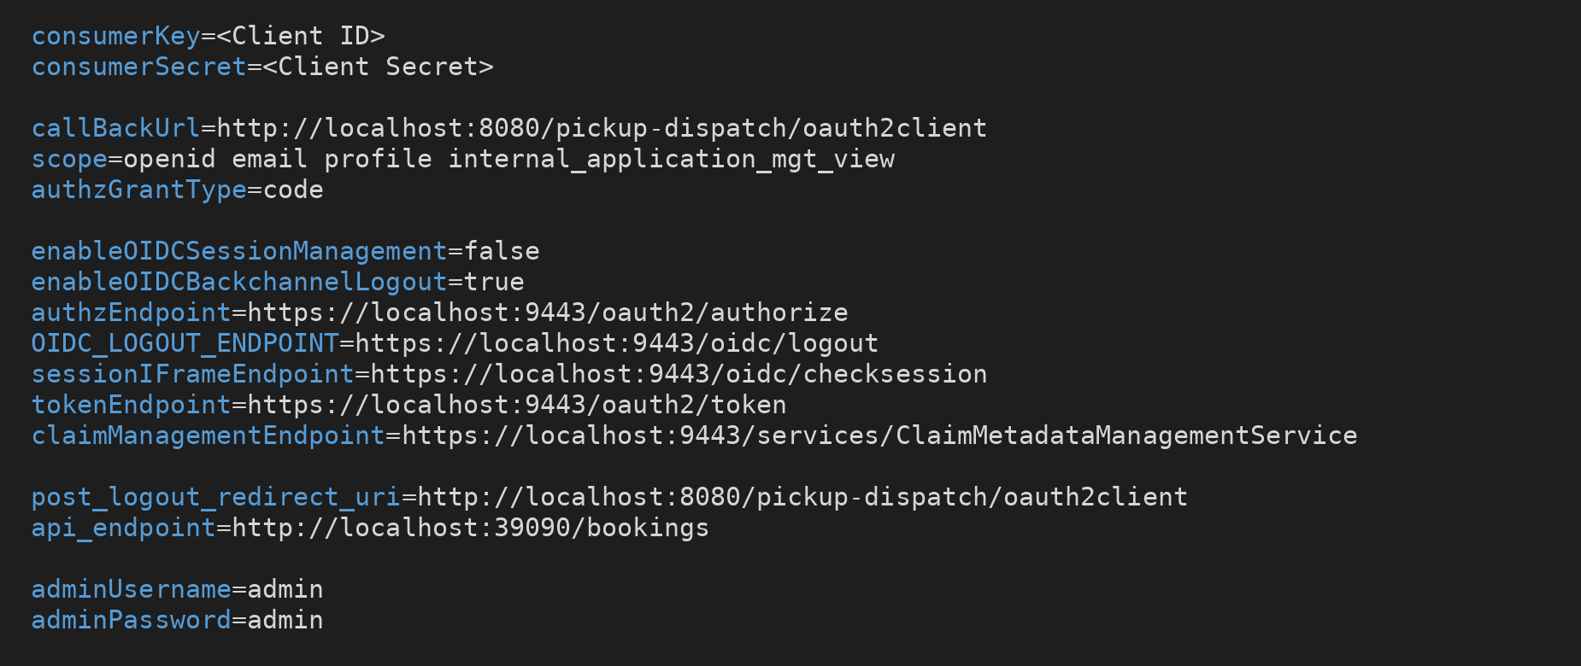

- Restart Tomcat: in <TOMCAT_HOME>/bin run catalina.bat stop and then catalina.bat start on Windows, or sh catalina.sh stop and then sh catalina.sh start on Linux and macOS.
- Get backend-service.jar from the 3. Resources folder of Day 10 (it is also in the SampleApps folder).
- Open a terminal (Command Prompt on Windows) in the folder that contains backend-service.jar and start the backend service. The command is the same on Windows, Linux and macOS:
java -jar backend-service.jar
The service listens on port 39090. Keep this window open while you do the lab.

The setup is now complete and you can proceed to try out the scenario.

Try It:
- Open http://localhost:8080/pickup-dispatch/index.jsp and log in with a user's credentials (for example admin / admin).
- By default, the backend calls are disabled. Therefore, enable it by ticking the Backend box in the drop-down list as shown in the diagram below:
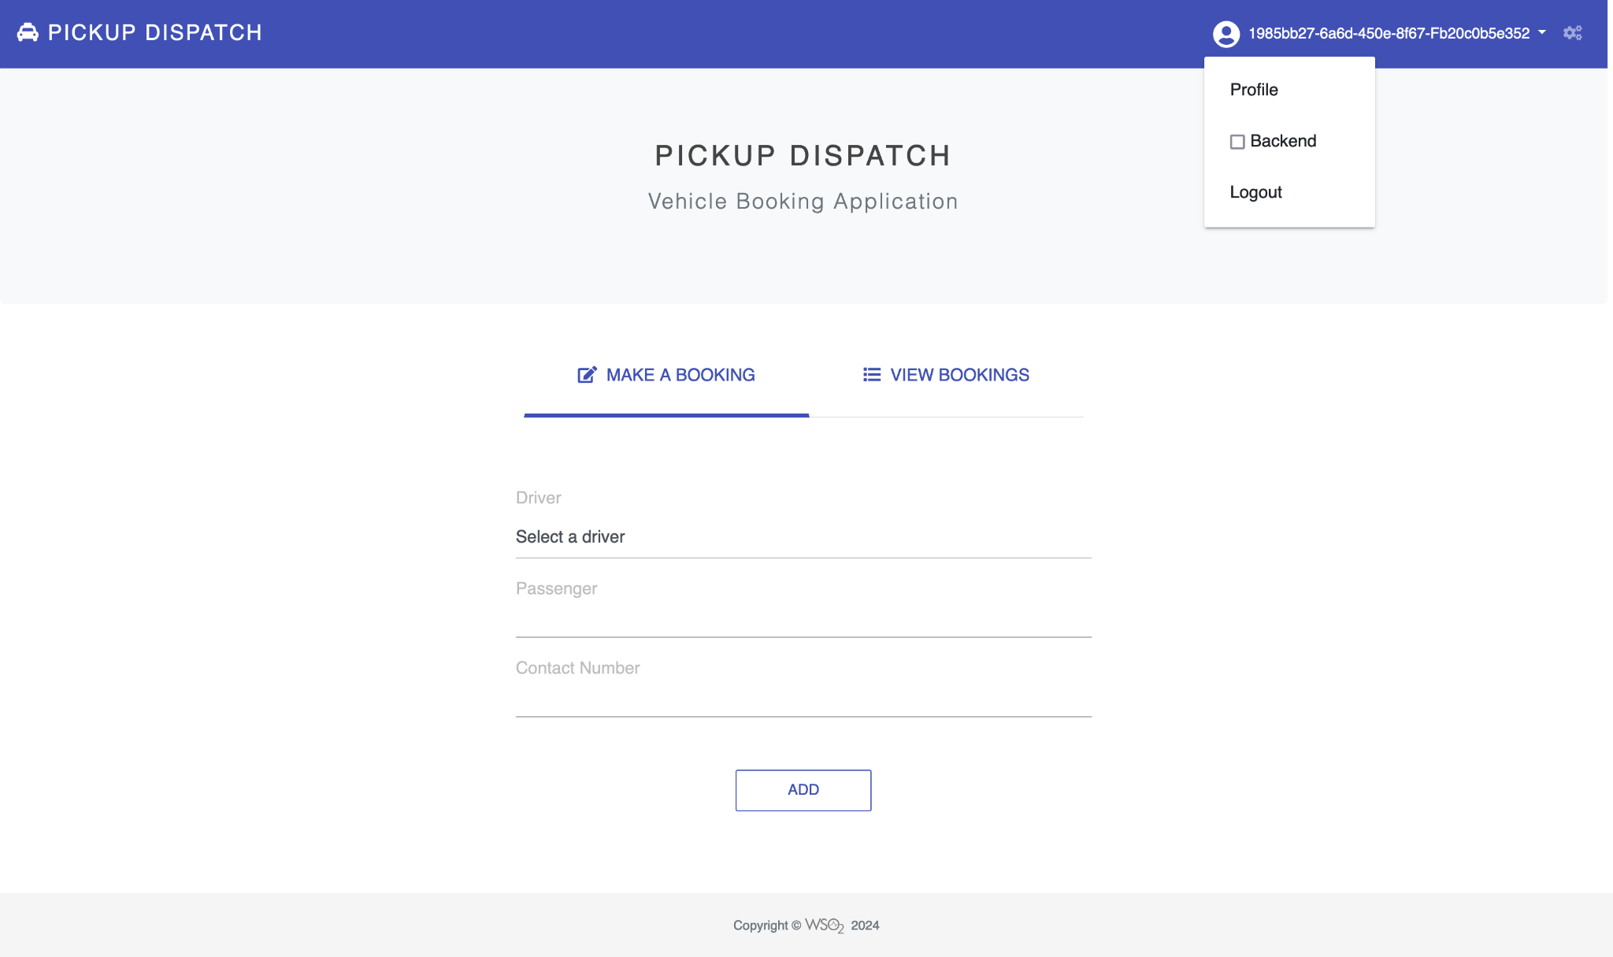

- Now we can add a new booking by selecting a driver from the drop-down list and filling passenger details. When you click on the Add button, you can notice the request sent to http://localhost:39090/bookings contains an authorization header.
- To see the token, open the browser's developer tools before you click Add (press F12, or right-click the page and select Inspect) and go to the Network tab. Click Add, then select the bookings request to http://localhost:39090/bookings. Under Headers > Request Headers you can see Authorization: Bearer <access token>: the access token that the application got from WSO2 Identity Server.
- Similarly, you can view stored bookings. This request too contains an Authorization header.

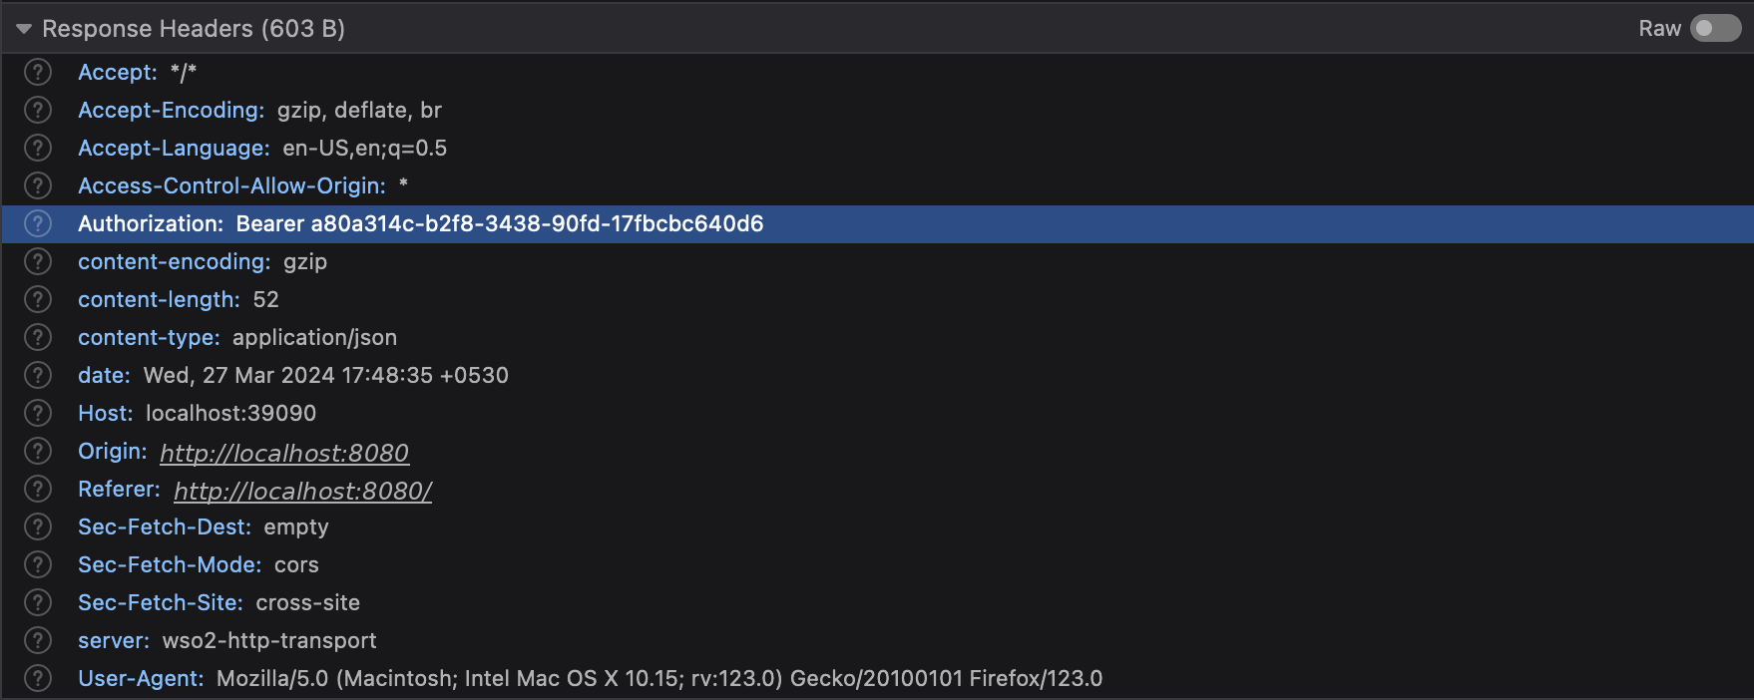
Note: the sample backend only receives the token. It does not validate it by default (token introspection is turned off in backend-service.jar), so a request without the header is not rejected. In a real deployment the API, or an API gateway such as WSO2 API Manager (Lab 13), validates the token and returns 401 Unauthorized when it is missing or invalid.

